Press Release

On Wednesday 22nd January 2020, Cllr Nicholas Busvine OBE, Mayor of Sevenoaks, and Sophie Woods-Scawen, launched the ‘Happy to Chat Bench’. Sophie contacted Sevenoaks Town Council at the end of last year to suggest we get involved in this nationwide scheme and we were more than happy to play our part in this fantastic initiative to combat loneliness.

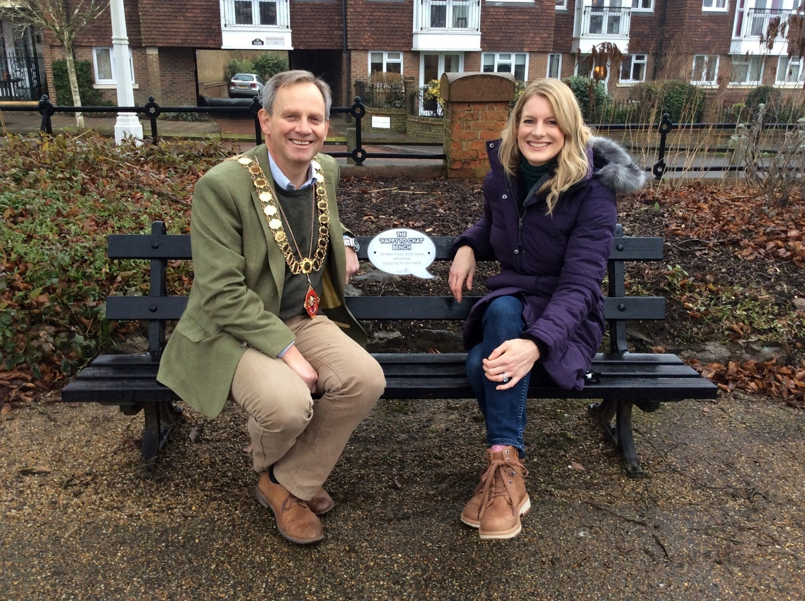

Steph Harrison
Committee Clerk
22.01.2020

